May 8th, 2011
Hi
Well, the birthday season is upon us again. First of all, its ‘Happy Birthday’ to Gavin for next Saturday. Take your pick of birthday cards! Actually, these are the ones I used last year!


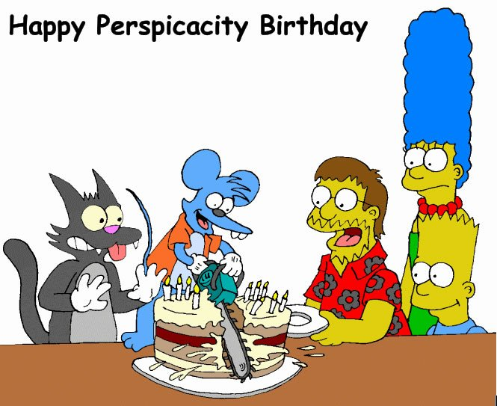

Not much to write about. HK's minimum wage law came into effect last Monday. There are still employers trying to get around the regulations so as not to have to pay more to their staff.
Of course the big news of the week was the announcement that Osama Bin Laden had been killed in Pakistan. After the initial reports, after the White House started to change its story about how he was killed, the reaction around the world was not quite as good. Then there is the report about the helicopter that crashed (?shot down) when landing in the compound. A report I heard said it was a secret stealth helicopter and that what remained of it was collected by the Pakistanis and is on its way to China which is also trying to build its own stealth helicopter. However, I only heard one report on this so do not really know how accurate it was.
The other day a reasonably large tornado hit Auckland. One person was killed and many buildings damaged or destroyed. Apparently, NZ gets about 20 tornadoes a year though most are very minor. And certainly this tornado could not compare with those that ravaged the southern US recently.

The US Navy has applied to China to allow the aircraft carrier USS Carl Vinson (pictured, from which bin Laden was buried at sea) to visit HK. Defence is one area that HK does not have control over in the “One country, two systems” policy. Permission for such visits is given by Beijing. HK is a popular R & R stop for the navy.
Oo Australian TV the other night there was a report of the death of the world's last remaining WWI veteran, at the age of 110. He was born in the UK and first saw action in 1916 at the age of just 15. Some time after the war, he migrated to Australia. Apparently the last US vet from WWI died not too long ago. There is still one lady who served in WWI alive but she served in a military restaurant rather than in active service.
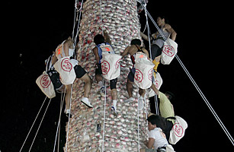
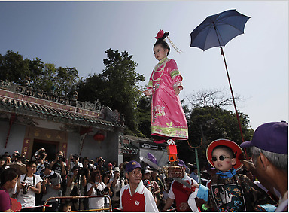
This week sees the annual Bun Festival on Cheung Chau with the actual scrambling up the bun towers on Tuesday night / Wednesday morning (I think). The festival in is honour on the sea goddess Tin Hau who supposedly rescued the island from both a plague epidemic and from pirates some time in the 19th Century. As well as bun towers, the festival is also notable for the procession in which children are carried above adults on stilts (hidden poles).
Also in HK, the fund which the government asked businesses/tycoons to set up to help the less well off has run into trouble. They were asked to donate $5 billion which the government (i.e. the taxpayer) would match dollar for dollar. But so far only $1.8 billion has been donated with about 1/3 of this coming from Li Ka-shing. Many tycoons actually said they would not donate. Now the government wants the legislative council to still approve $5 billion of public funds instead just a matching $1.8 billion. The council is currently refusing to do so. One of the problems with the scheme is that the government announced it, with great fanfare, before first finding out how much tycoons would actually donate.
I have extended my lease here for another year, a year being the maximum length of time it can be extended. Again there has been an increase in rent which, taking into account a discount, is about 7.6% higher than last year. Still this is a bit better than a year ago when the rent was raised by about 22% from the preceding year.
That seems to be it for now.
Cheers

